PLEASE READ THE INSTRUCTIONS CAREFULLY AND CLEARLY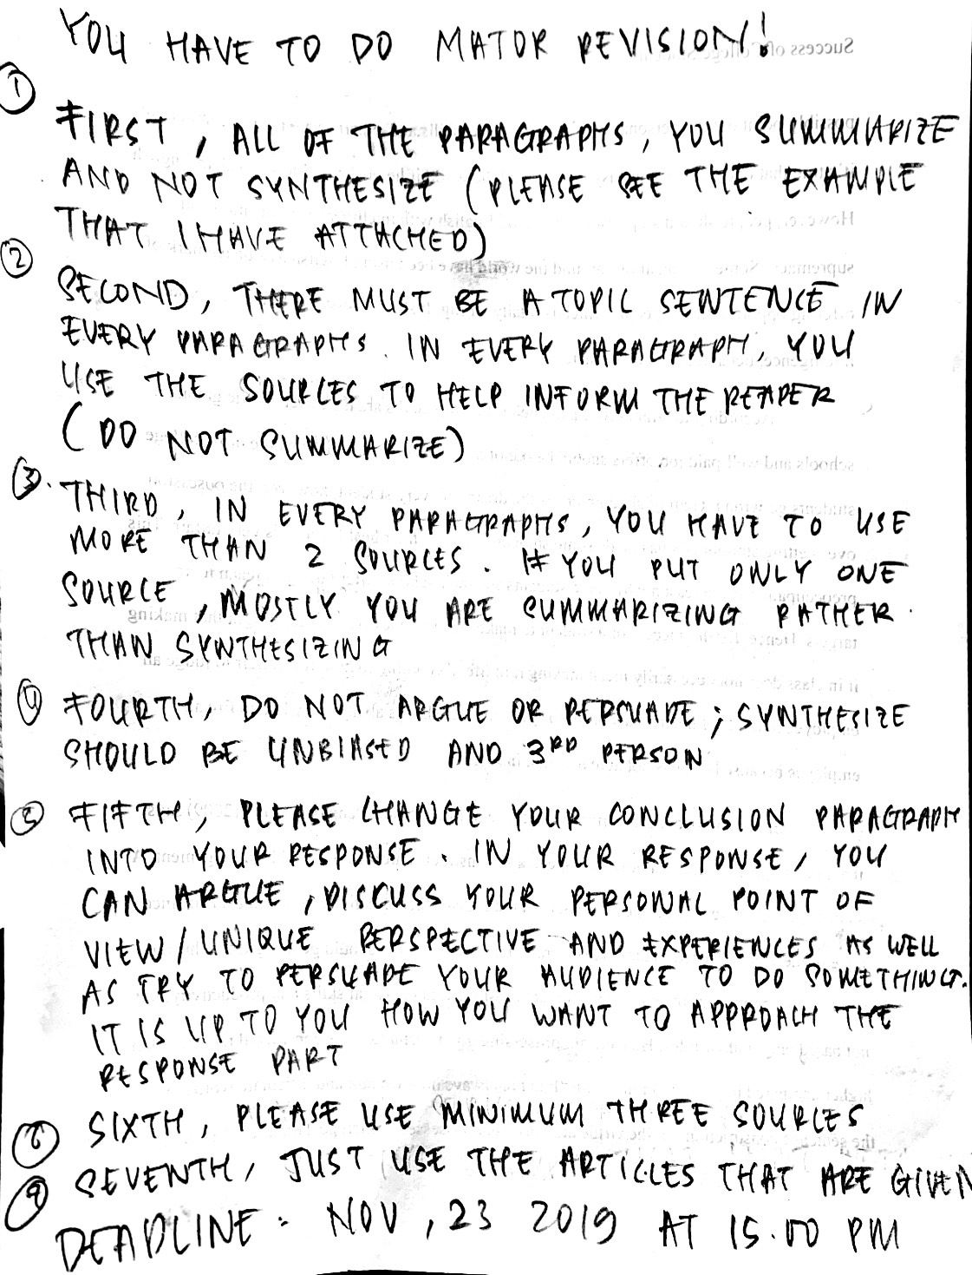

EXAMPLE OF SYNTHESIZE THAT I WANT YOU TO DO FOR THIS ASSIGNMENT. LOOK HOW THE READER USES THE VARIED SOURCES. DO NOT SUMMARIZE BUT SYNTHESIZE. PLEASE USE THE SOURCES TO HELP INFORM TO THE READER. FOR ME, THE USES OF MANY ARTICLES IS TO SUPPORT OR EMPHASIZE YOUR TOPIC SENTENCES. REMEMBER NOT TO ARGUE OR PERSUADE.

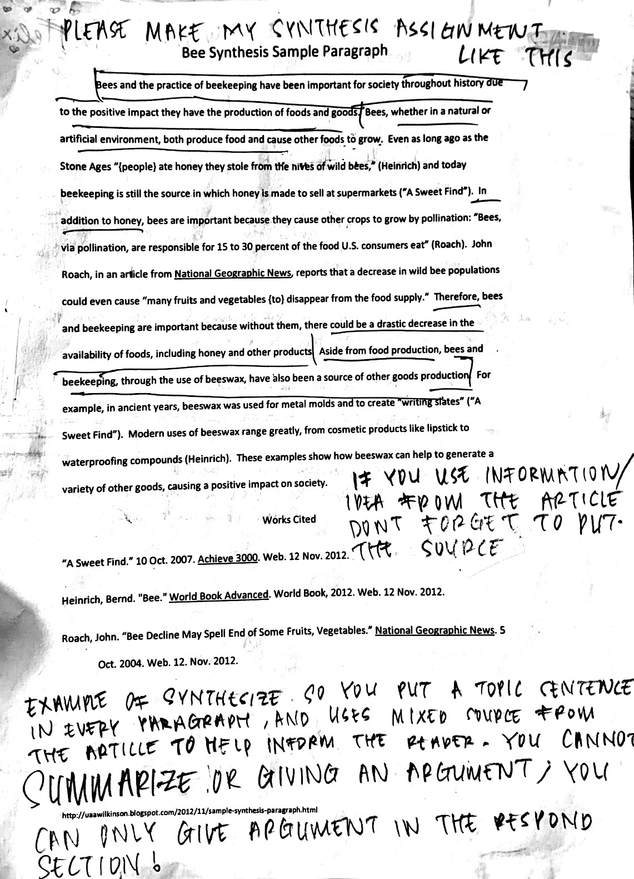

HERE IS MY PROFESSOR’S FEEDBACK, BUT SHE ONLY GIVES ME LITTLE BIT OF FEEDBACK.
SHE TOLD ME THAT I NEED TO DO BIG REVISION, SINCE I SUMMARIZE RATHER THAN SYNTHESIZE.
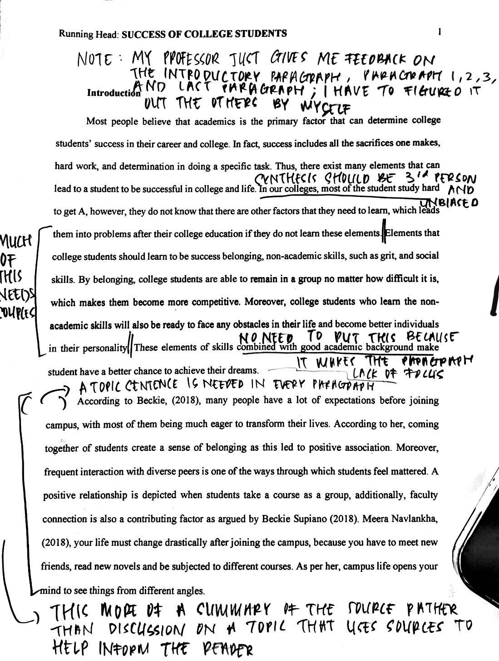

IT MUST BE UNBIASED AND USE THIRD PERSON

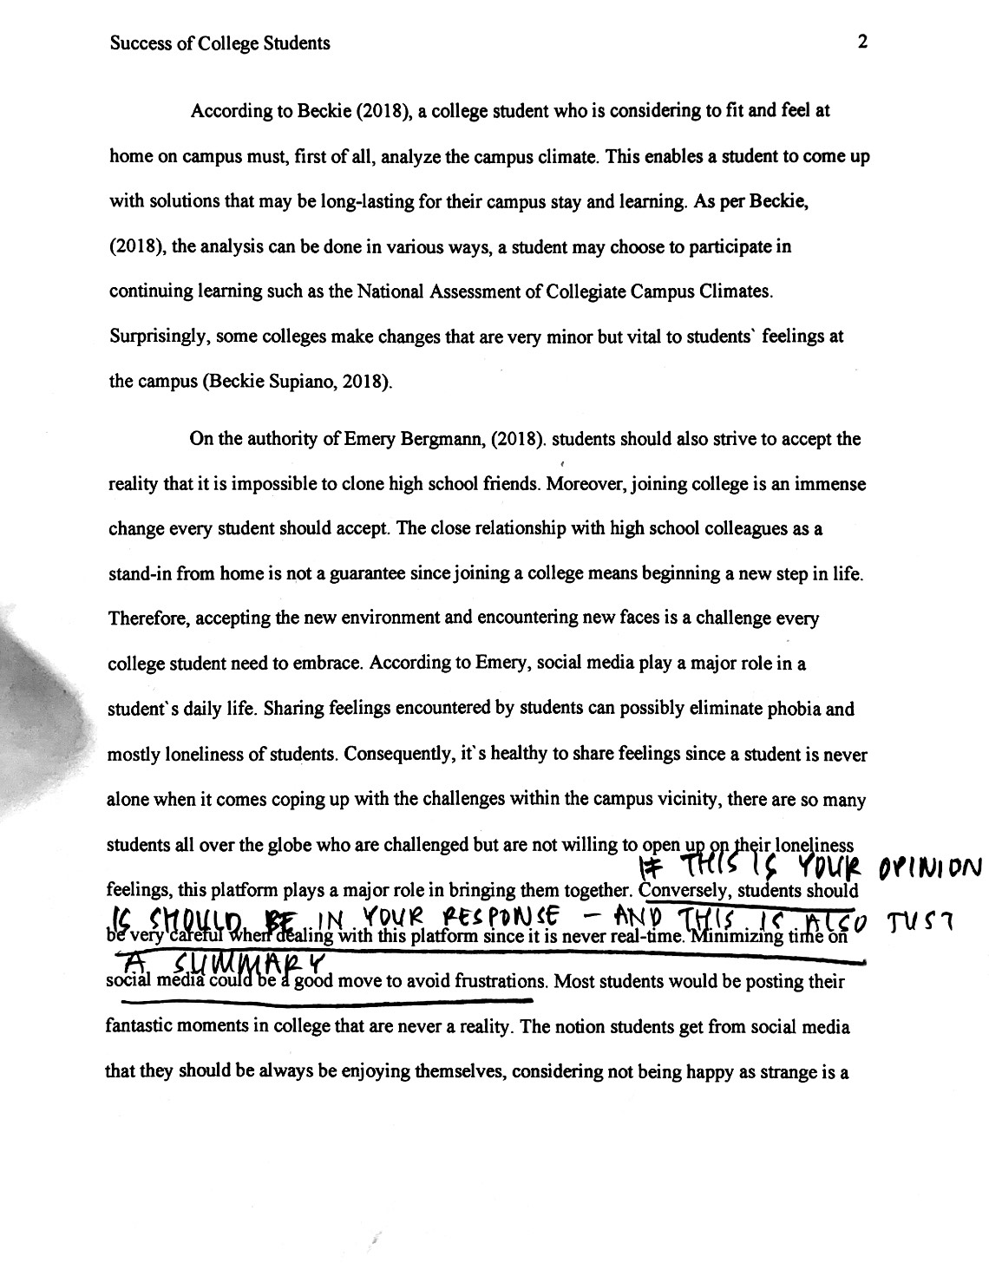

PLEASE CHANGE YOUR CONCLUSION PARAGRAPH TO BE YOUR RESPONSE PARAGRAPH, WHICH IS EASIER FOR YOU TO FULFILL THE MINIMUM WORD NEEDS RATHER THAN SYNTHESIZING EVERYTHING.

JUST READ THE INSTRUCTIONS. ASK ME IF YOU DO NOT UNDERSTAND
DEADLINE: NOV 23, 2019 AT 15.00 PM

PREVIOUS FILE:

Introduction
Most people believe that academics is the primary factor that can determine college students’ success in their career and college. In fact, success includes all the sacrifices one makes, hard work, and determination in doing a specific task. Thus, there exist many elements that can lead to a student to be successful in college and life. In our colleges, most of the student study hard to get A, however, they do not know that there are other factors that they need to learn, which leads them into problems after their college education if they do not learn these elements. Elements that college students should learn to be success belonging, non-academic skills, such as grit, and social skills. By belonging, college students are able to remain in a group no matter how difficult it is, which makes them become more competitive. Moreover, college students who learn the non-academic skills will also be ready to face any obstacles in their life and become better individuals in their personality. These elements of skills combined with good academic background make student have a better chance to achieve their dreams.
According to Beckie, (2018), many people have a lot of expectations before joining campus, with most of them being much eager to transform their lives. According to her, coming together of students create a sense of belonging as this led to positive association. Moreover, frequent interaction with diverse peers is one of the ways through which students feel mattered. A positive relationship is depicted when students take a course as a group, additionally, faculty connection is also a contributing factor as argued by Beckie Supiano (2018). Meera Navlankha, (2018), your life must change drastically after joining the campus, because you have to meet new friends, read new novels and be subjected to different courses. As per her, campus life opens your mind to see things from different angles.
According to Beckie (2018), a college student who is considering to fit and feel at home on campus must, first of all, analyze the campus climate. This enables a student to come up with solutions that may be long-lasting for their campus stay and learning. As per Beckie, (2018), the analysis can be done in various ways, a student may choose to participate in continuing learning such as the National Assessment of Collegiate Campus Climates. Surprisingly, some colleges make changes that are very minor but vital to students` feelings at the campus (Beckie Supiano, 2018).
On the authority of Emery Bergmann, (2018). students should also strive to accept the reality that it is impossible to clone high school friends. Moreover, joining college is an immense change every student should accept. The close relationship with high school colleagues as a stand-in from home is not a guarantee since joining a college means beginning a new step in life. Therefore, accepting the new environment and encountering new faces is a challenge every college student need to embrace. According to Emery, social media play a major role in a student`s daily life. Sharing feelings encountered by students can possibly eliminate phobia and mostly loneliness of students. Consequently, it`s healthy to share feelings since a student is never alone when it comes coping up with the challenges within the campus vicinity, there are so many students all over the globe who are challenged but are not willing to open up on their loneliness feelings, this platform plays a major role in bringing them together. Conversely, students should be very careful when dealing with this platform since it is never real-time. Minimizing time on social media could be a good move to avoid frustrations. Most students would be posting their fantastic moments in college that are never a reality. The notion students get from social media that they should be always be enjoying themselves, considering not being happy as strange is a fallacy. Embracing uniqueness is a virtue that students need to adopt in campus life (Emery Bergmann, 2018).
Character plays a major role in a student`s college life and success in general. The United States has a long history of character education since the 1930s. According to Anya Kamenetz (2015), a student should develop character strengths such as grit, zest, optimism, self-control, gratitude, curiosity and social intelligence. As said by Leyla Bravo-Willey of KIPP Infinity, “We're not religious, we're not talking about ethics, and we’re not going to give any kind of doctrine about what is right from wrong”. The elements of character, for instance grit and self-control are thus necessary to prepare students for excellence.
Additionally, the growth mindset is a necessity for a student. It is believed that positive traits, as well as intelligence, can be realized through practise as opposed to fixed mindset which argues that the duo set at birth. Thus, every student is required to acquire these through practice; forming group discussions as well as responding positively to staff care support can make it possible. For a student`s success, mindset should be positive.
Emotional, social and soft skills play a major role in shaping up a student is facing challenges and fitting in the society (Anya Kamenetz, 2015). Emotional skills are acquired right from childhood and are needed throughout the course of life. Emotional skills can be seen from student`s behaviours such as expression, goals as well as motives. Behaving socially is with colleagues is such a desirable move that not only show the character but also improve the well-being of a student. In addition, soft skills are also a requirement in the realization of success. Usually, employers refer to soft sills as intangible and non-technical abilities demonstrated by students, for instance, showing up in time and offering a firm handshake. Soft skills could possibly point out the personality of a student. The skills and expertise are the most important. it’s true that one can have an easy way around the world if he or she is able to speak in English. However, people should stop associating good English with intelligence, civilization and supremacy. Some organizations around the world have been using English as a benchmark of offering opportunities to people which is totally wrong. It should never be used as a measure of intelligence, behaviour or the character.
According to Grant (2018), the belief that top marks are the ticket to elite graduate schools and well-paid job offers should be out of a student`s mind. This is where most college students go wrong. Getting good grades is the dream of every student, however, the obsession over getting straight A`s has made some students sacrifice their health which is very unfair. This preoccupation is the reason why some students sue their schools after failing to reach their targets. Hence, for the success of a student to make it in life, they have to get it right that making it in class does not necessarily mean making it in life. According to him, it is unfair to judge an employee in terms of his/her capability to speak in English. It’s always very bad to fire an employee because he/she is not able to speak in English.
Grammar is not necessarily the measure of intelligence. Penelope Trunk (2009) says that judging people based on how they speak and construct sentences is a snobbish judgement. A student should strive to judge people based on their ideas, their creativity, and enthusiasm since none of these are attached to the issue of grammar. Every student should get it right that hiring and firing of employees in an organization are mostly based on social skills and productivity, but not based on grammar rules. Henceforth, possessing good social skills is considered to be a notch higher compared to good grammar skills. It is not always how we talk and articulate words, or the sentence construction but the virtue an individual possesses (Penelope Trunk, 2009). On the other hand, there are some grammar rules that when violated the sentence meaning might be completely distorted, thou in rare cases. In as much as good grammar may reveal the sort of education an individual had, the rules are not actually useful. As a result, for a student to be successful in college and life he/she need to shun snobbish judgement based on an individual`s grammar.
Conclusion
It is always a challenge for any student to be successful in college and life in general. Nonetheless, when students develop the habit of coming together despite the race or background success is realized. Additionally, embracing the change of climate and environment as well the new faces can lead to adaptive life. Being judgmental on grammar is a setback that needs to be shunned by students too. Since good getting straight A’s does not directly prove intelligence, students should mainly focus on outside campus life as making it in class does not mean making it in life. As far as character and other other non-academic skills are concerned, the success of a student is entirely based on the conduct. Therefore, college students have to be excellent not only in the academic but also in the non-academic skills if they want to be success in their career and college.

